**3-Tier Architecture**

1.create vpc:

* Go to vpc and then click on vpc more to create vpc with subnets.
* We hate to create 2 public subnets and 4 private subnets.

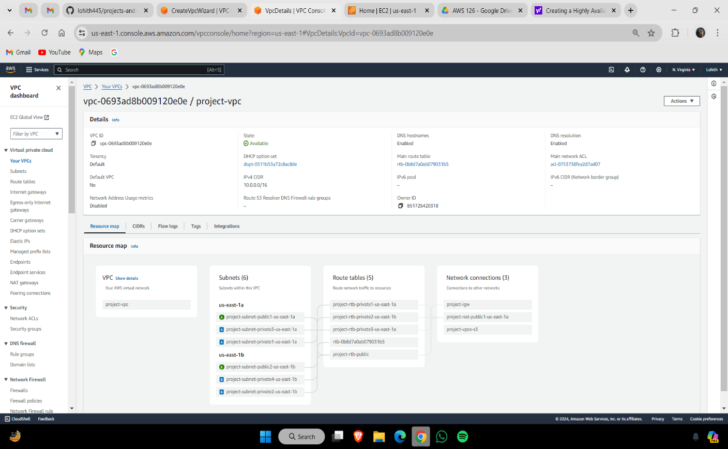

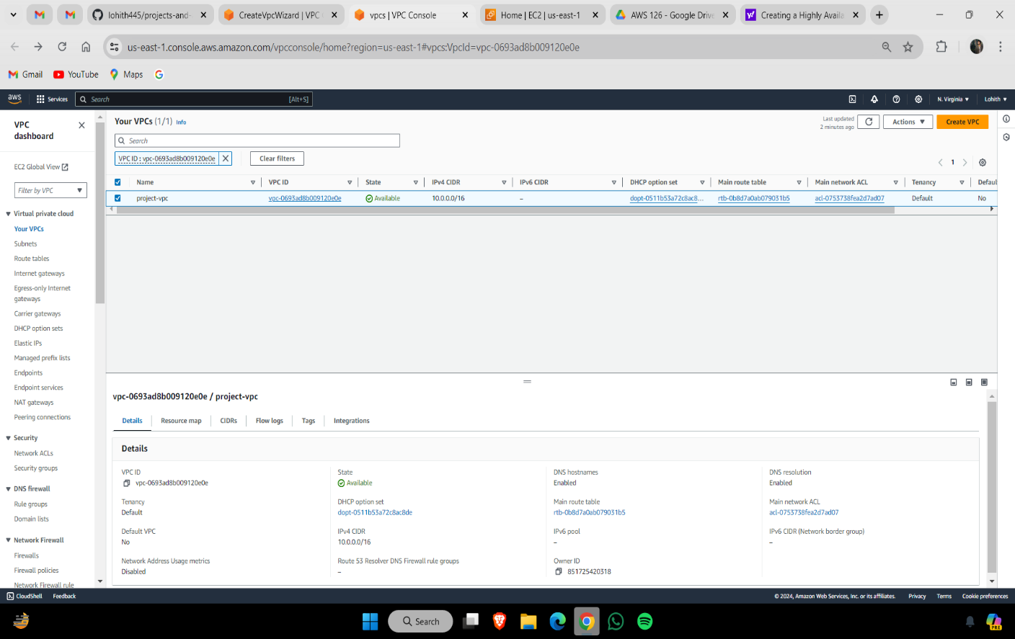

2.Subnets:

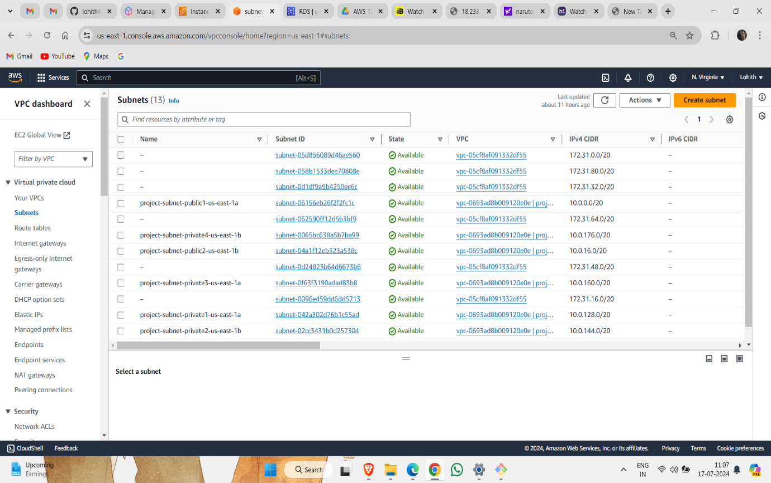

3.Next we have to attach the vpc to internet gatway,that the vpc more option it directly attach the vpc to internet gatway that it will helps in time saving.

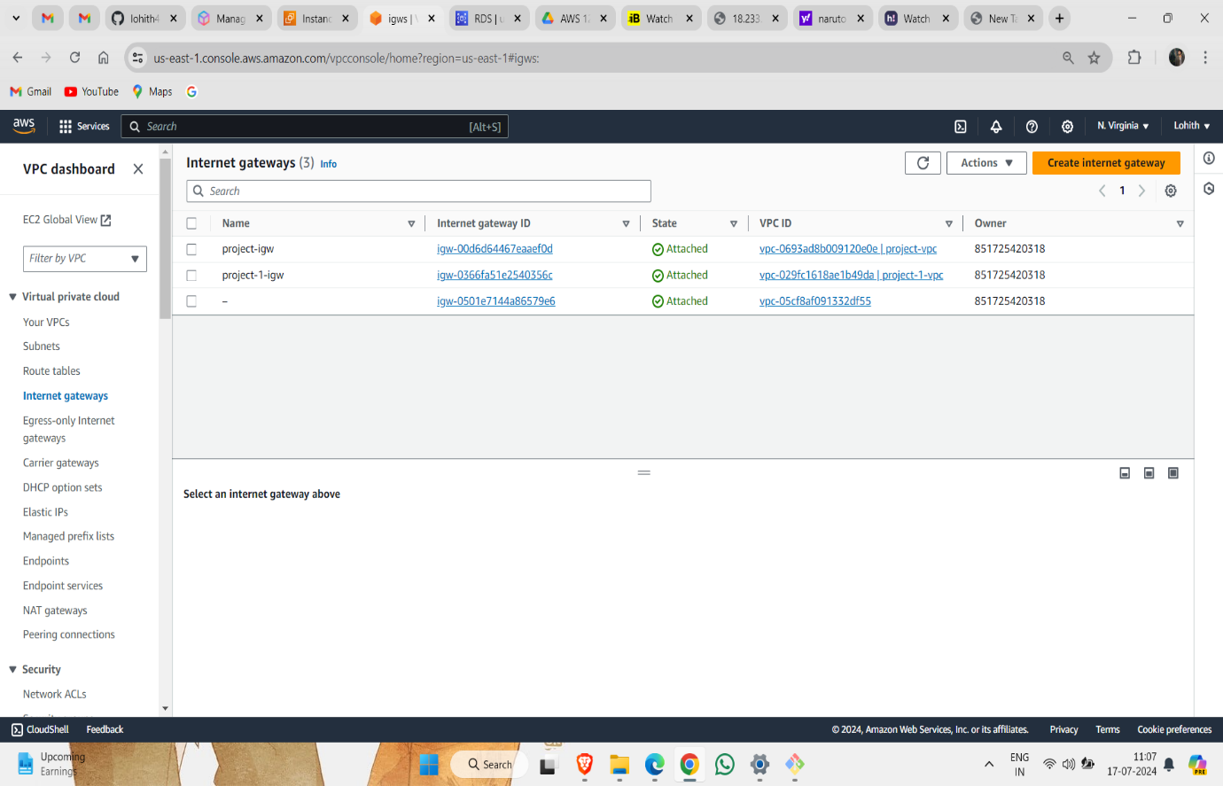

4.Next we have to attach the vpc subnets to the route table ,that the vpc more it directly attach the subnets to route table.

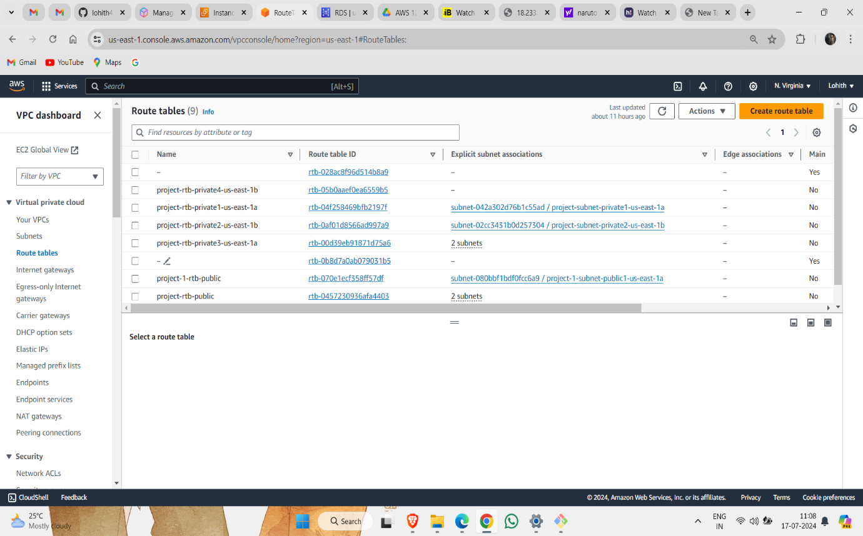

5.Create NAT Gateway and attach it to Public Subnet

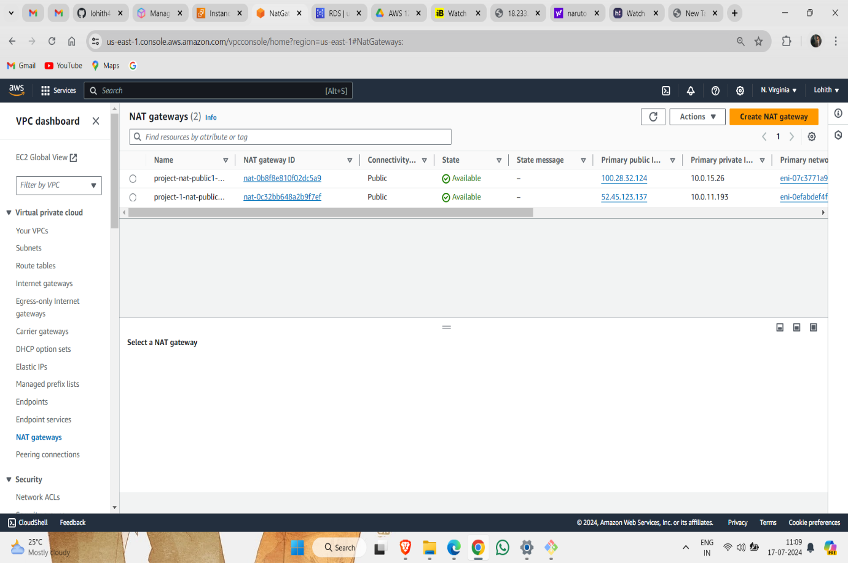

6.create ec2 instance to the public and private subnets that it have to connect the ec2 instane

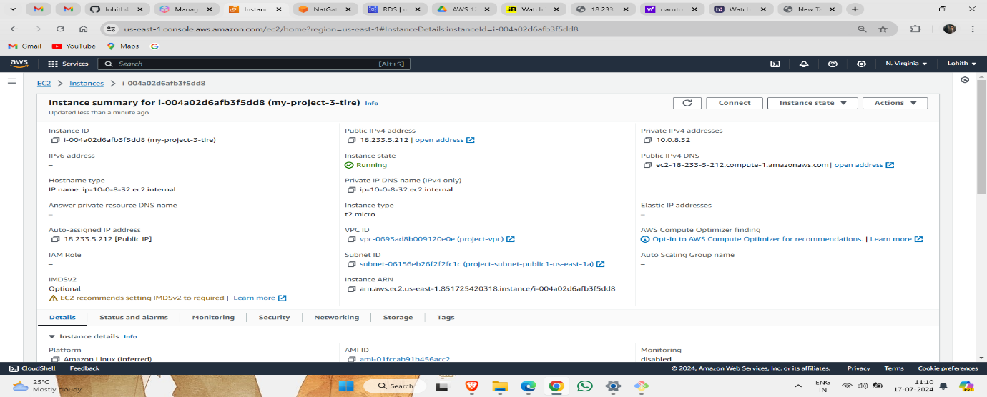

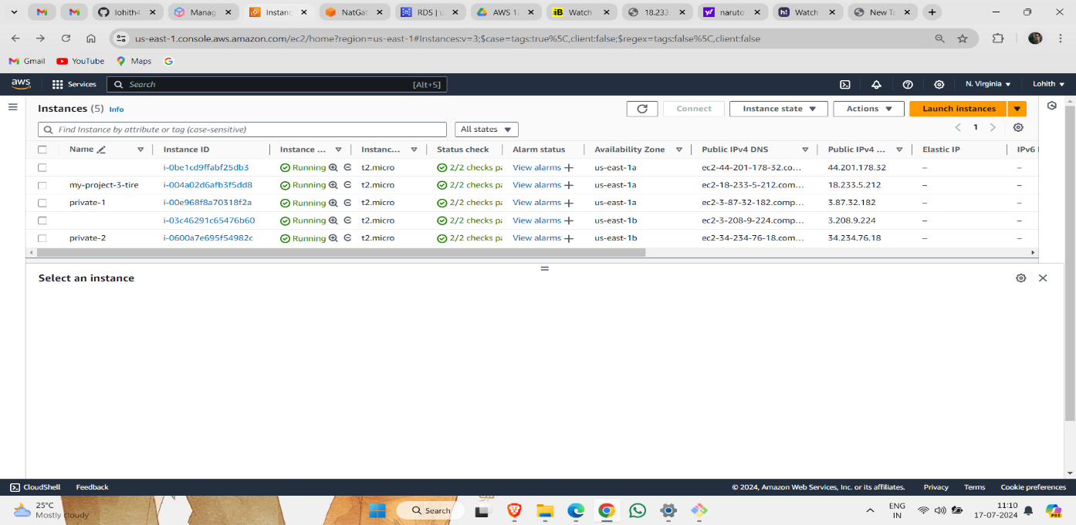

7.Connect Ec2 to server

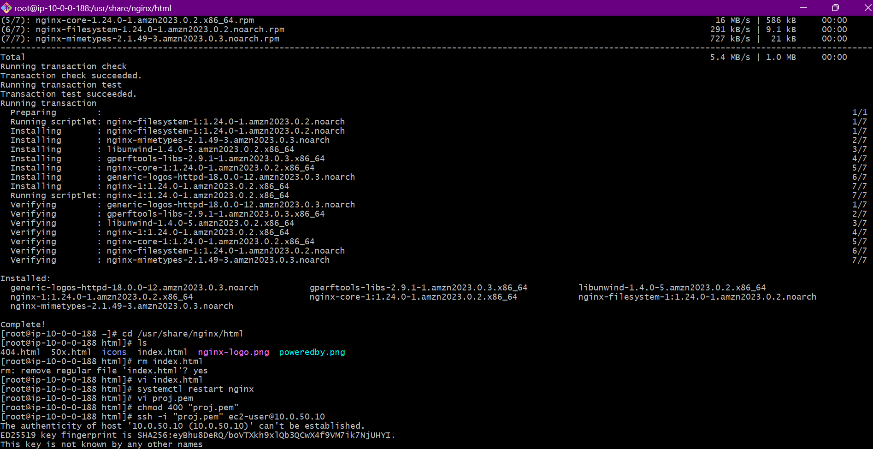

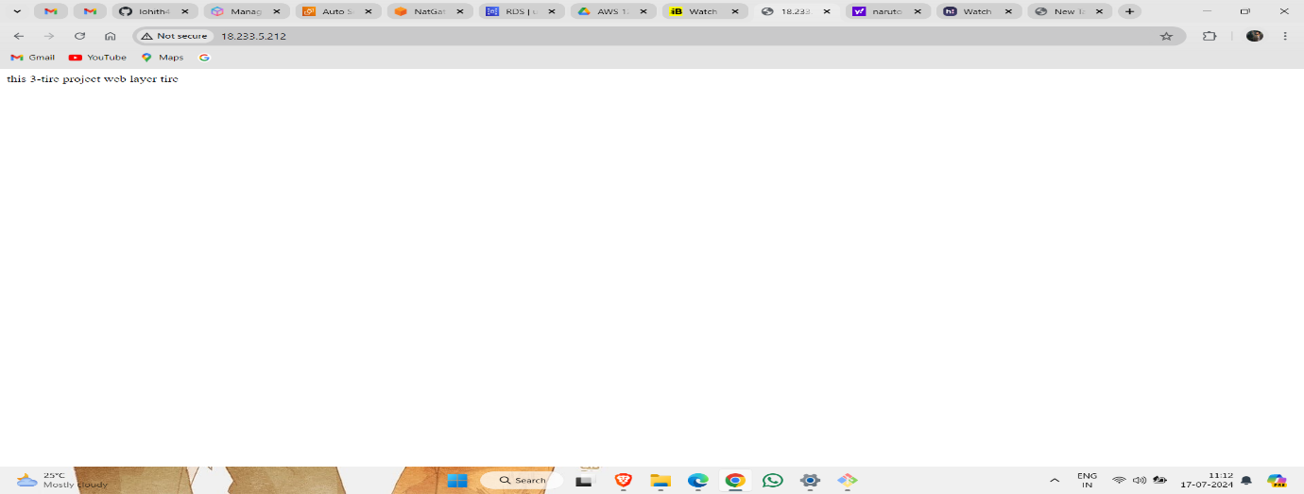

8.create launch templates

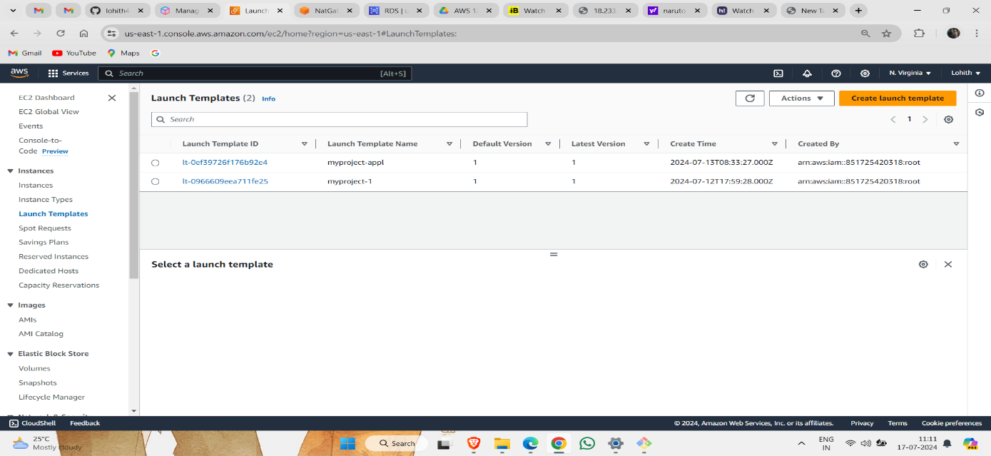

9.Create load balancer

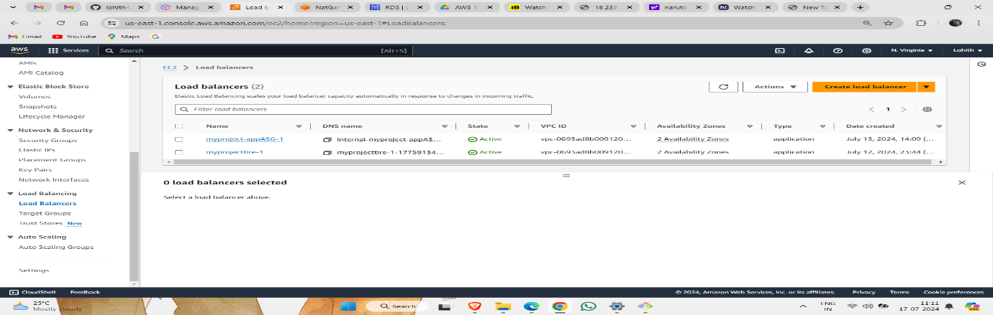

10.Create target group

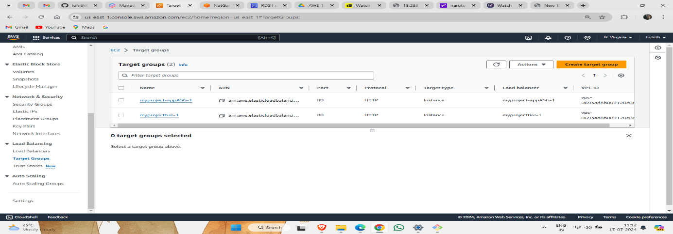

11.Create AMIs

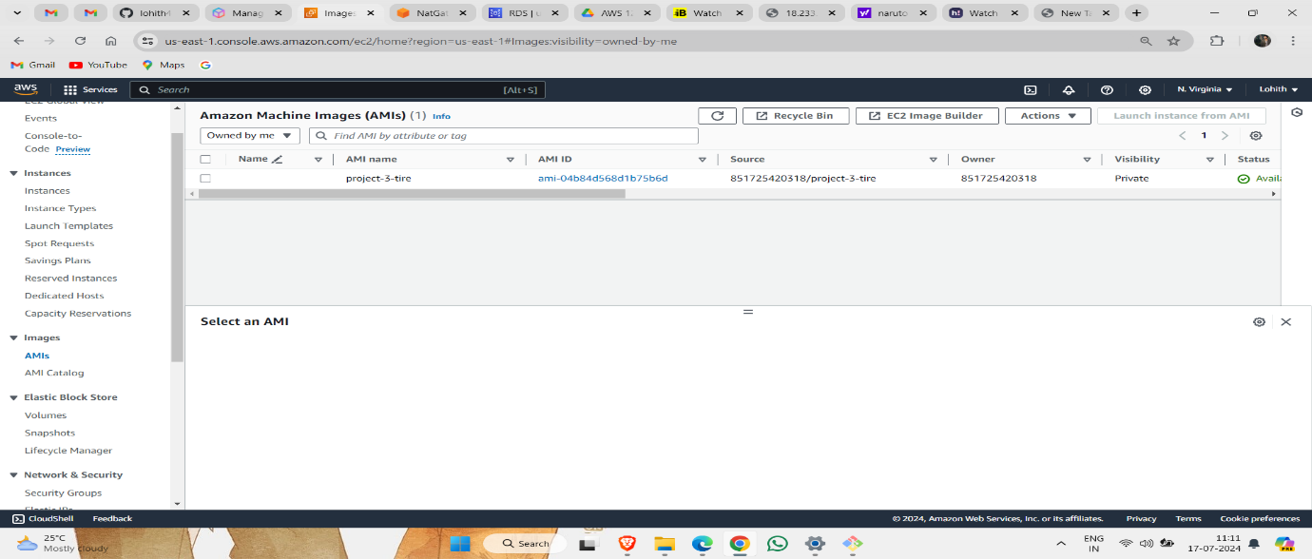

12.Create auto scalling

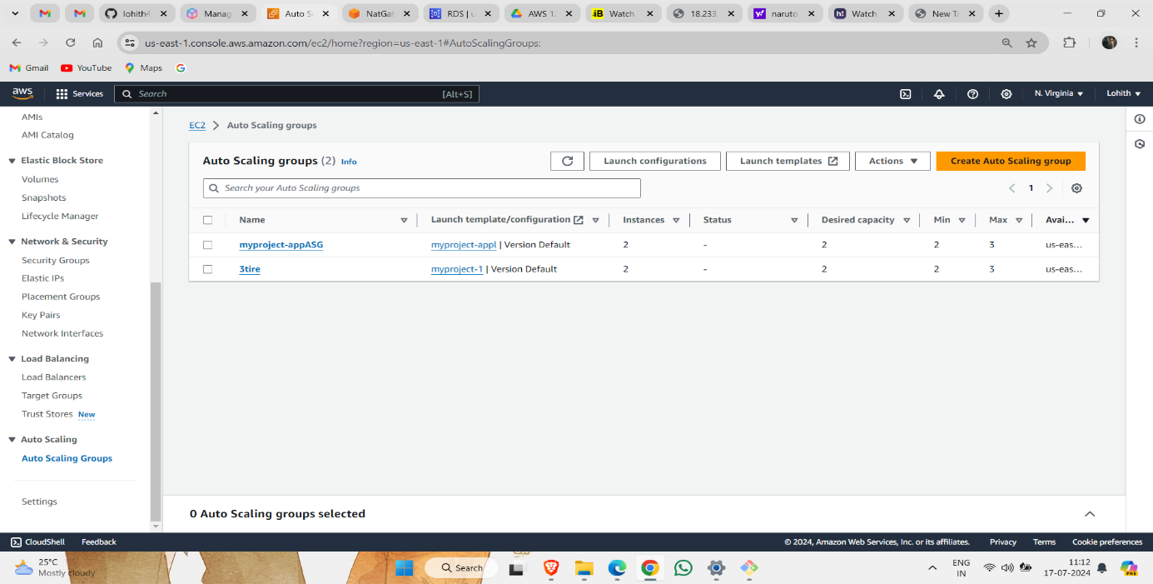

13.Creating RDS

First we have to create subnet group in the RDS

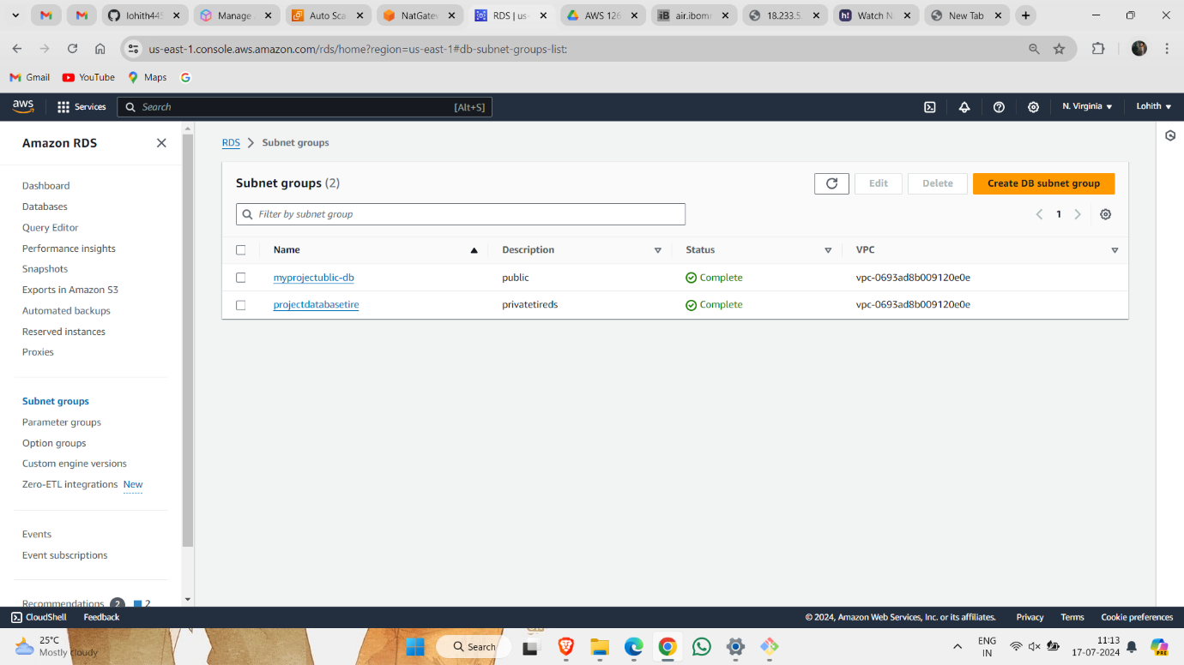

Next we have to create the database to the project

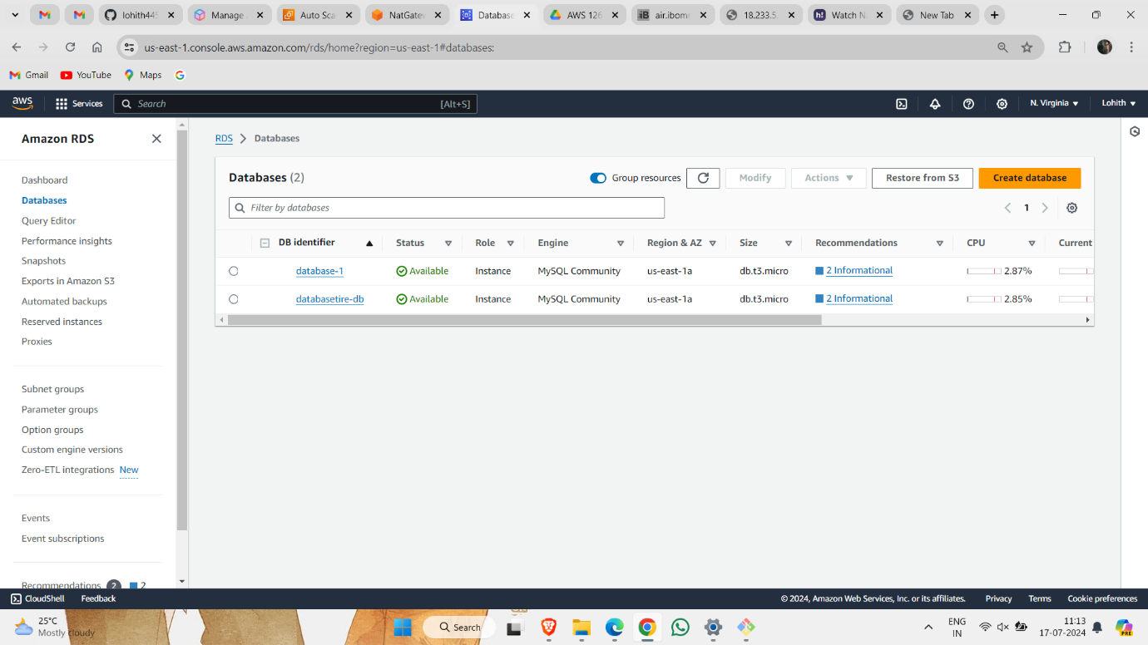

We have to coonect the RDS to the server and install mysql and create the database table then the project is completed .

